
Telehealth for Smart Phones and Tablets (iOS and Android)

Overview
Telehealth Tasmania provides an easy, safe and secure way to videoconference with your clinician from any iOS or Android device.

Requirements
- Android or iOS device with a forward-facing camera, microphone and speakers. You may also prefer to use headphones.

- Internet connection – For a good experience you will need at least 0.4Mbps for both download and upload. You can test your Internet connection speed here by selecting Begin Test. Please be aware that a 15 minute videoconference will use approx. 130 megabytes of your download limit.

Downloading the Pexip Infinity Connect App
Go to the Google Play Store (Android) or the iTunes App Store (Apple): and search for Pexip Infinity Connect. Follow the instructions to install the app on your preferred device.

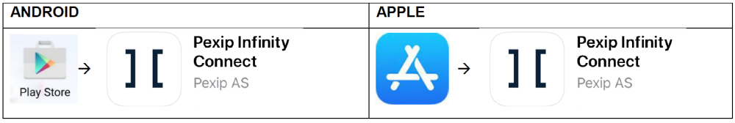

Opening the App
Find the installed Pexip Infinity Connect app on your device and tap to open.

Setting up the App
Follow any on screen prompts to allow access to Calendar, and Camera.
Android devices may show the following prompts:
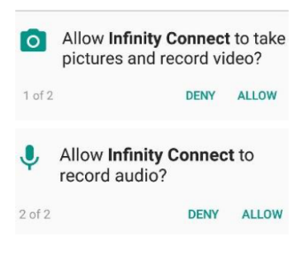
Please note, these are standard Android messages.
No Telehealth consultations are recorded and all calls are secured using industry standard encryption.

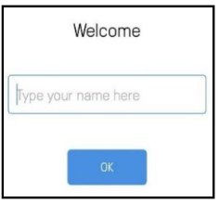

At the Welcome screen, enter your name as it should be shown to
your other VC participant/s.

Starting your Videoconference
From the main screen, tap the green “Video” button.
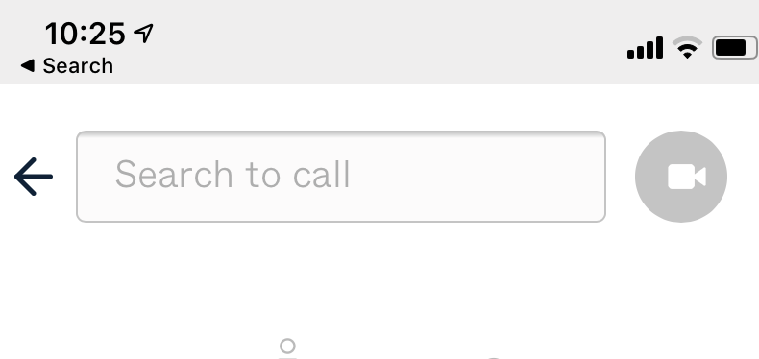

In the “Search to call” field type in the “Dial Number”@inviewuc.cloud that you have received in your email from Telehealth Tasmania then tap on the green video icon to initiate the call.

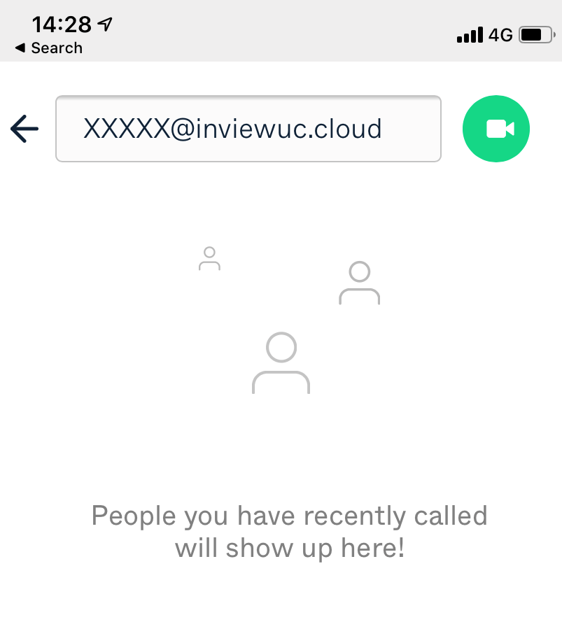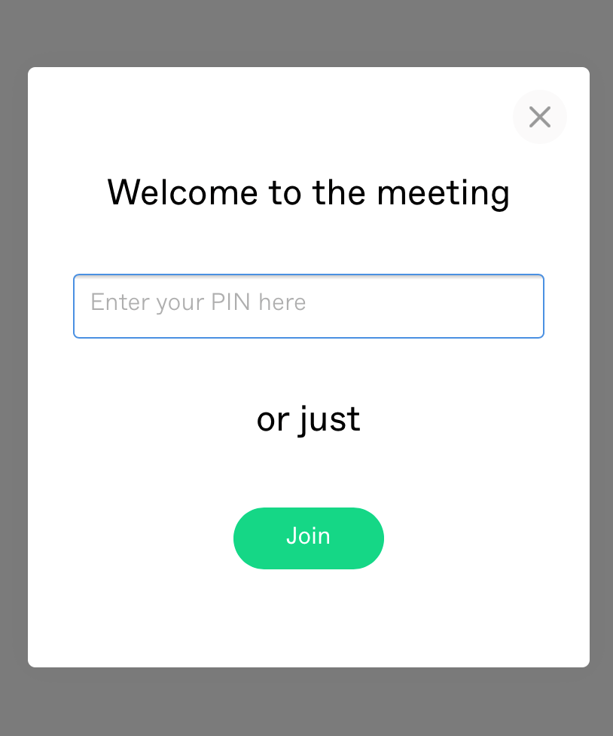

*Tap the side bar to bring up additional information about the Conference.
**Tap the three dots at the top to bring up settings (to change the camera and microphone.

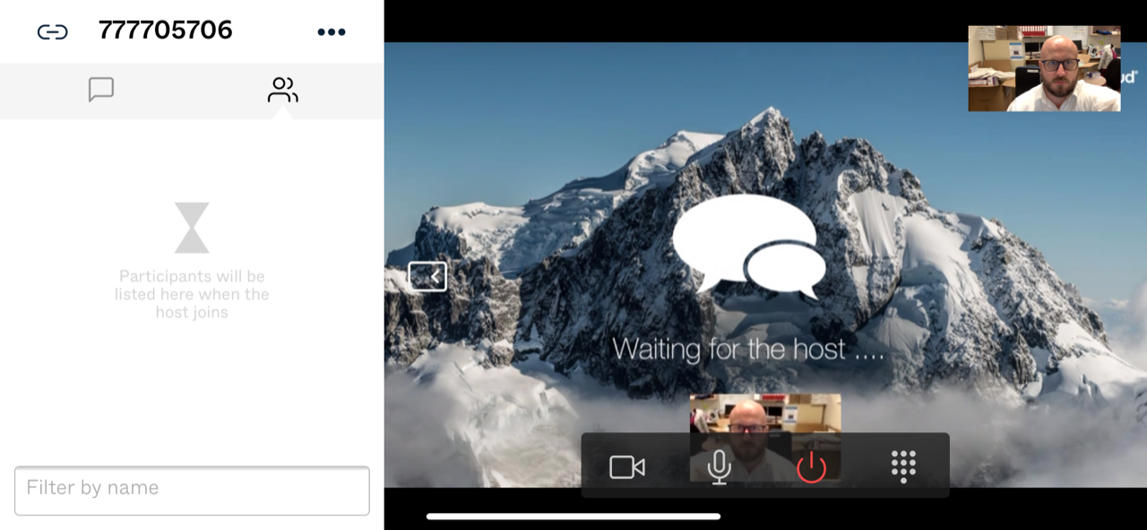

***It is best to use your phone or tablet in landscape mode once you have started your call.
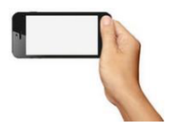
To test your connection before your conference please dial “test_call@inviewuc.com.au” to connect into our test bridge which is available 24/7. You have a successful connection if you can hear the audio announcement and repeat as directed.

Videoconference Controls

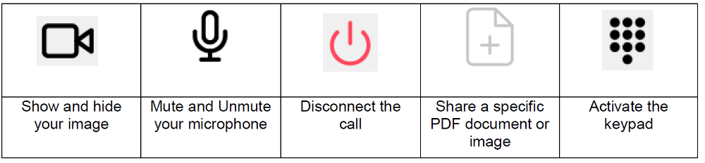

Troubleshooting

Problem | Solution
Quality and Bandwidth Issues  - Poor quality audio and video  - Call drops out | - Disconnect the call and click on the three dots that appear on the main screen (to the left of the name you entered upon setup of the app)  - Select Bandwidth icon  - Choose a lower bandwidth such as Low (256kbps) and reconnect the call  - Check if any other applications on your network are using the Internet and close them down
Camera and Audio Issues  - No self-view  - Can’t hear anything in the conference | - Check the webcam and audio settings are correct:  -   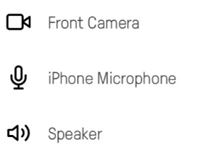
Connection Issues  - You are getting coloured shapes circling on the screen or no video connection or an error message  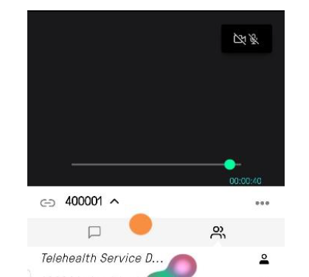 | - Check the dial address you have entered is correct.  - You will need to make sure @inviewuc.cloud is at the end of the number.  - The dial number you have been given may be incorrect. Please contact Telehealth Tasmania on 1300 027 894 to confirm these details.
Echo and high-pitched sounds while in a videoconference | - If using computer speakers, try using a pair of headphones instead  - Keep your microphone muted when not talking, unmute when needed
Last updated April 2020 – Modified with permission from Queensland Health
Telehealth Tasmania - Telehealth for Smart Phones and Tablets (iOS and Android)

